Table Description
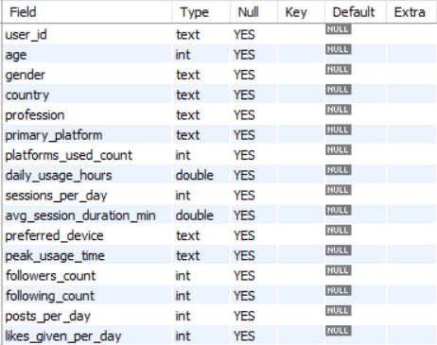

Fetch all Records
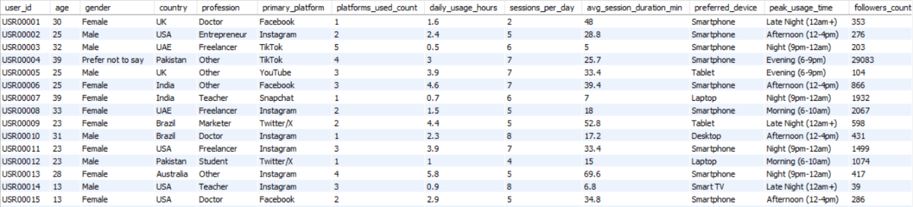

Q1. Count total users
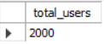

Q2. List all unique social media platforms.
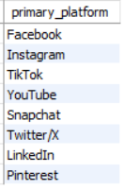

Q3. How many users are on each platform?
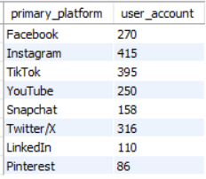

Q4. Find the top 10 users who spend the most time daily.
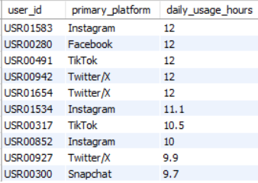

Q5. What are the average engagement metrics per platform?
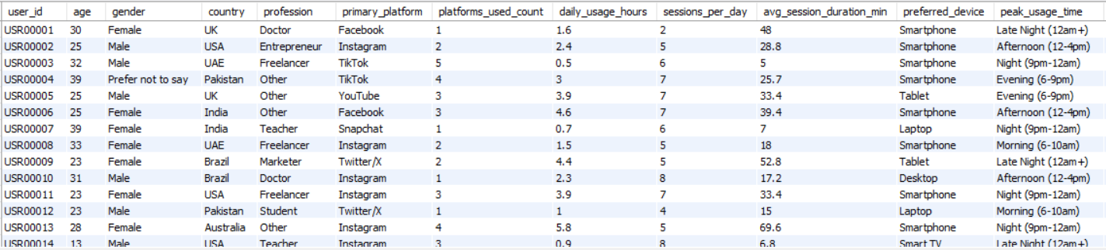

Q6. Most active platform by total posts
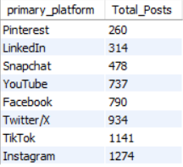

Q7. Which Platform have highest average followers
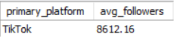

Q8. Categorize users by daily usage level
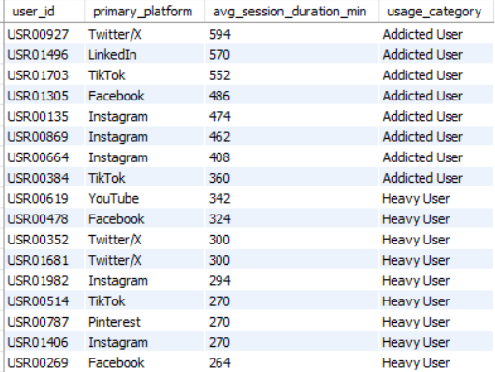

Q9. Rank each platform by user count, avg time, avg likes
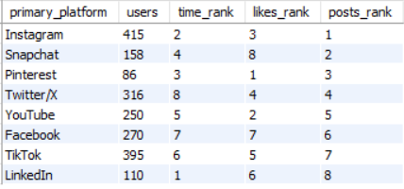
Q10. Country-Wise Average Followers Count
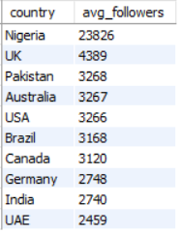

Q11. Find countries having more than 100 users.
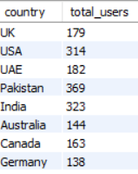

Q12. Find average screen time by country.
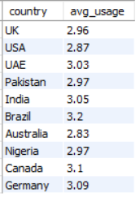

Q13. Count users by gender.
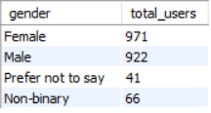

Q14. Find users whose followers count is above average.
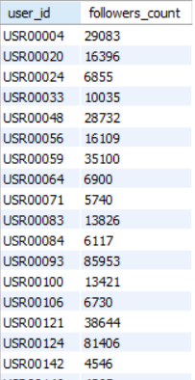

Q15. Find second highest followers count.
